

**ECEN 5053-003 Homework Assignment**

Course Name: Embedding Sensors and Actuators

Corresponding Module: C2M3

Week Number: 7

Module Name: DC Motors

Submitted by: Poorn Mehta

Part 1: Each question is worth 10 points.

1. The current loop below represents an electric motor. What is the torque on this motor if the magnetic field strength = 6 Tesla, the length of the loop is 0.50 meters, the current in the loop is 2.50 amps, and the radius of the loop is 0.10 meters. The rotational speed of the loop is 1065 RPM.

What is the torque on the loop measured in N-m? What is the Back EMF on the loop measured in volts?

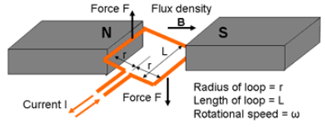

Answer: **1.5Nm, 66.918V**

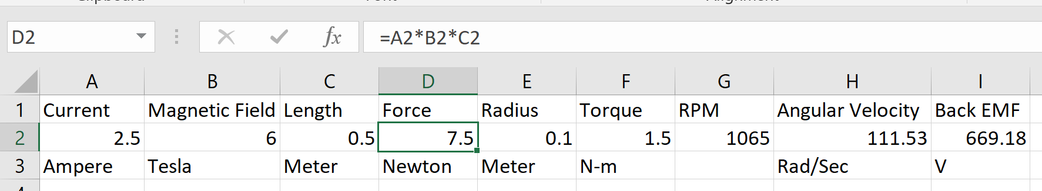

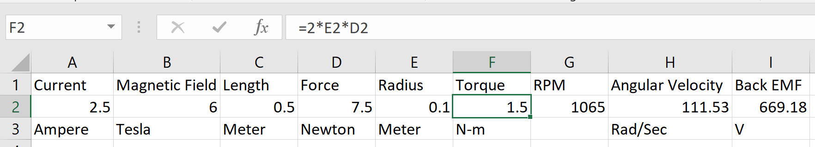

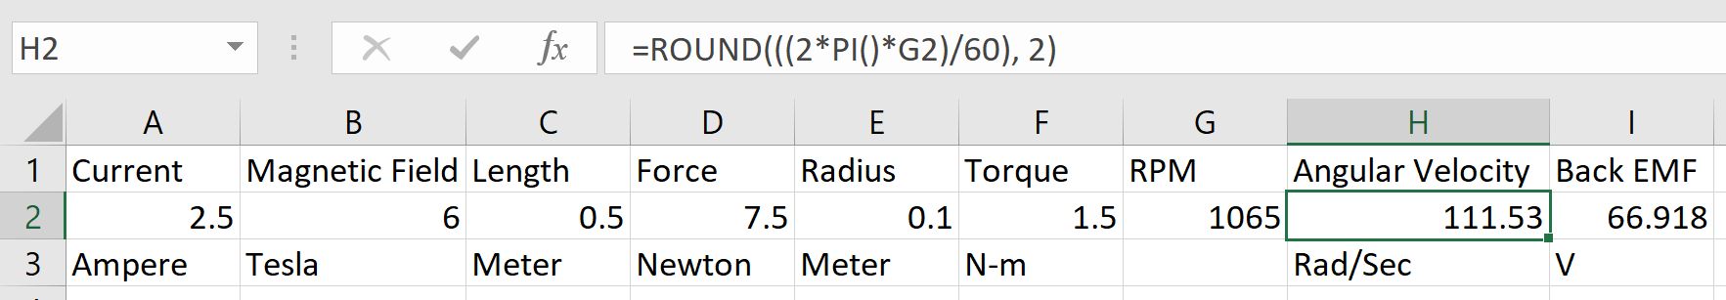

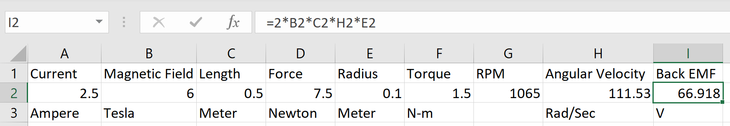

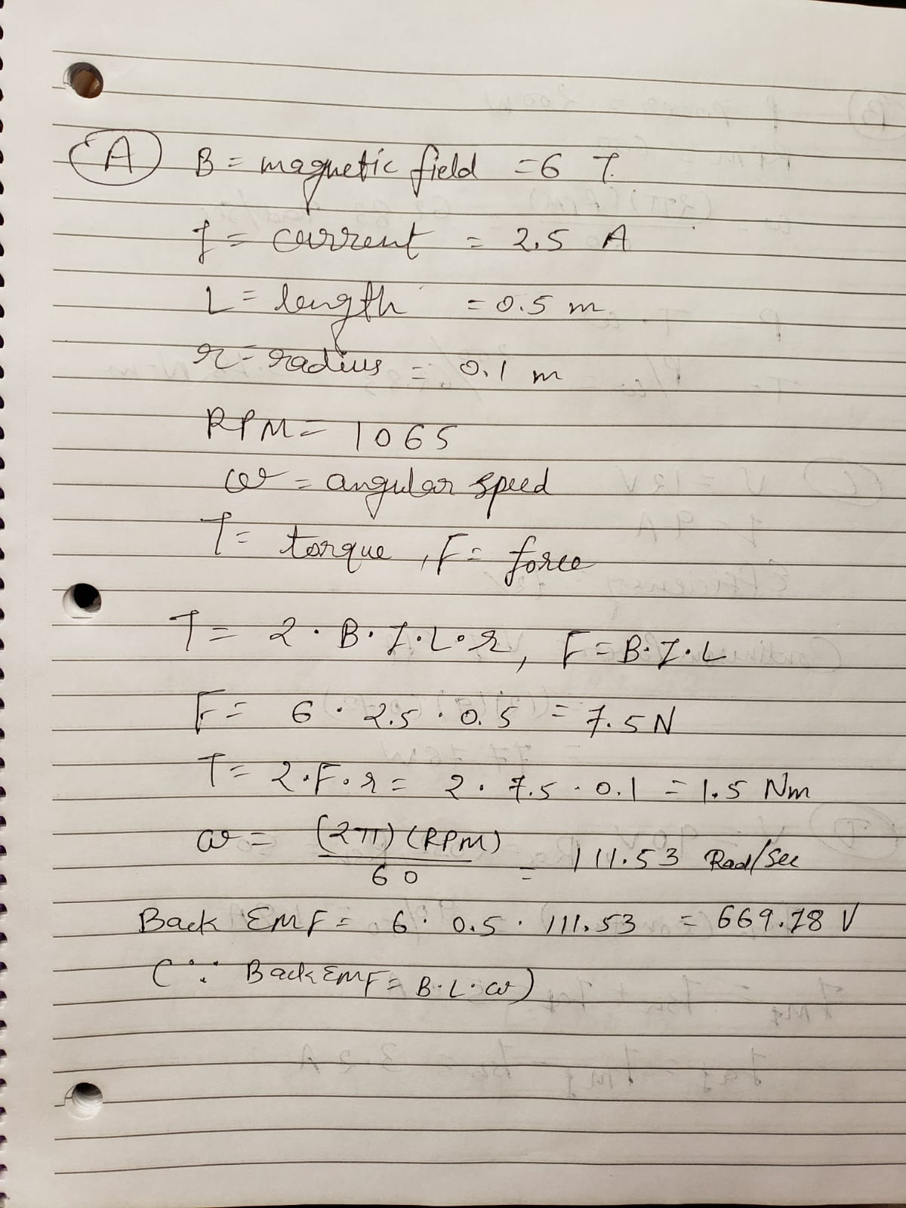

1. What is the torque in N-m of a DC motor operating at 600 RPM and 200 watts of power?

Answer: **3.18Nm**

Reference: [**[1]**](http://lancet.mit.edu/motors/motors3.html)

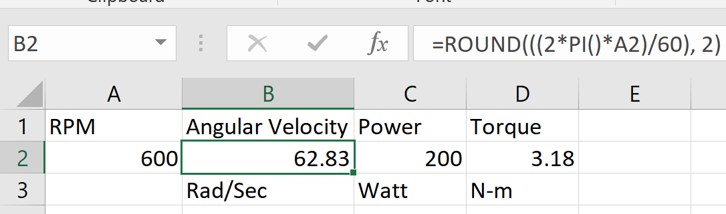

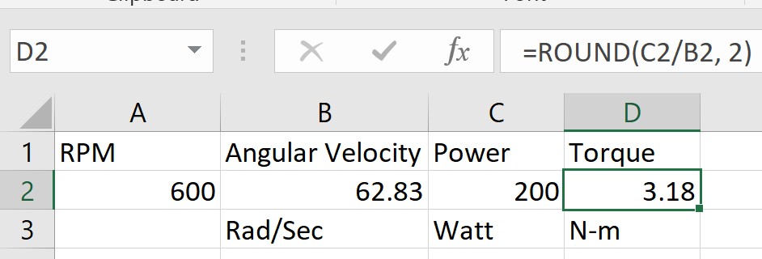

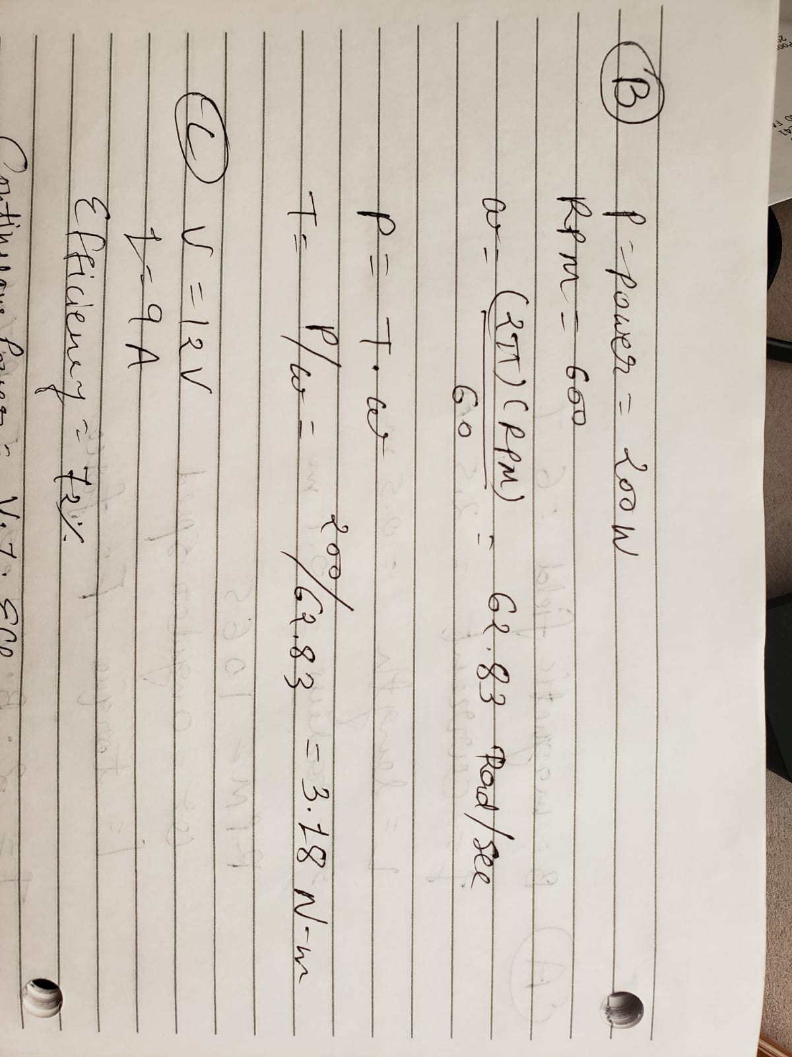

1. A brushless DC motor is rated at 12 volts, 0.9 amps, and operates at a duty point efficiency of 72%. What is its rating for continuous power?

Answer: **77.76W**

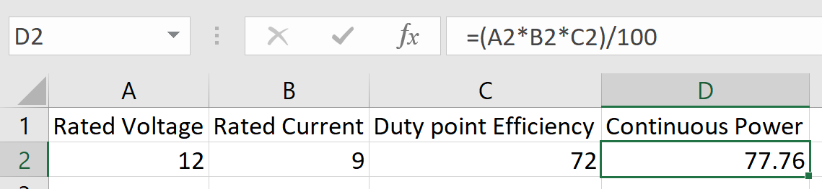

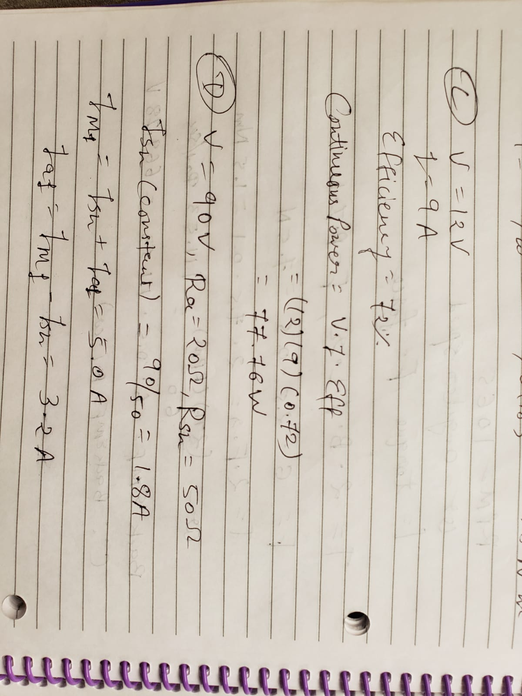

1. A shunt wound DC motor is operating in the linear range, and it has the following attributes:



What is the new speed and the new torque when the motor current is run at the new current, ILN?

Answer: **846RPM, 10.625Nm**

Reference: [**[2]**](https://www.top-ee.com/dc-shunt-motor/)

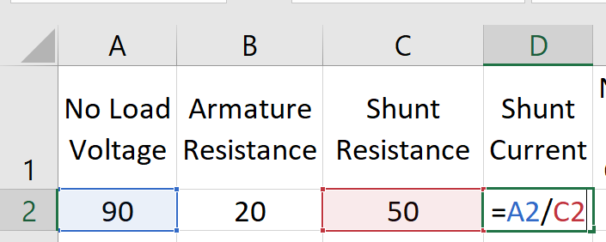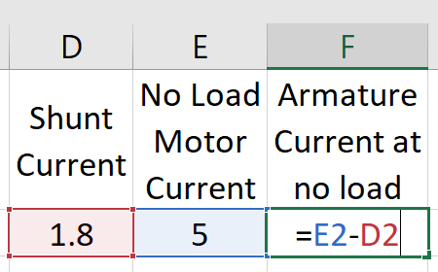

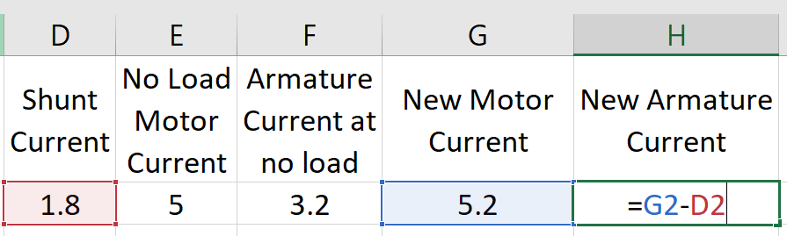

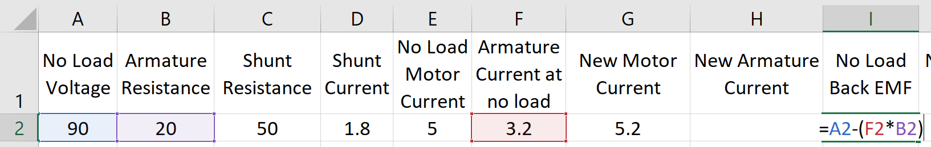

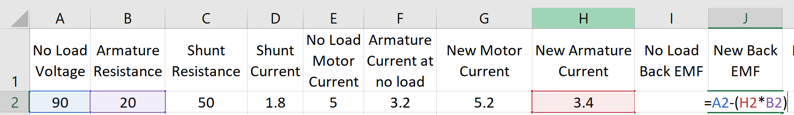

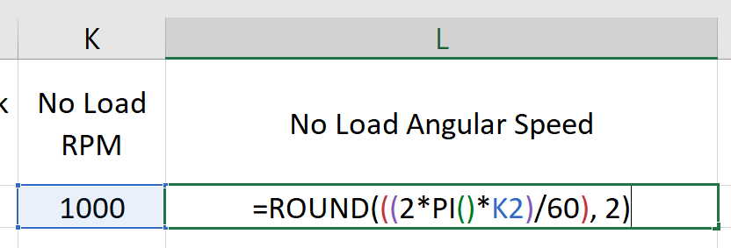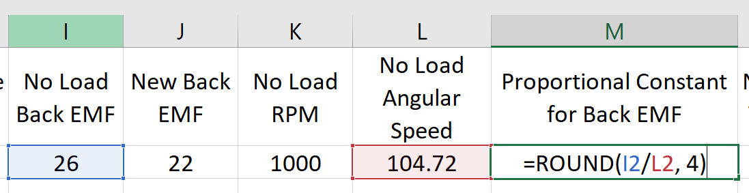

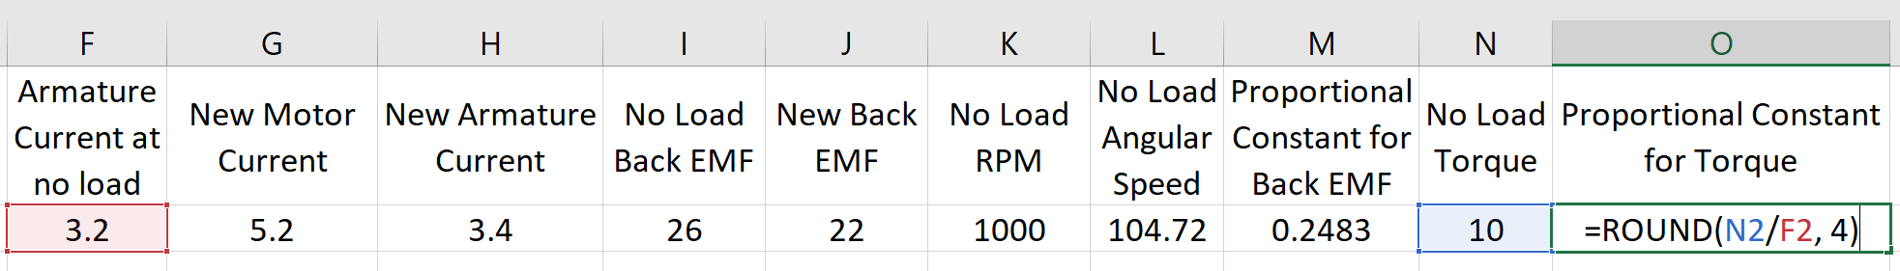

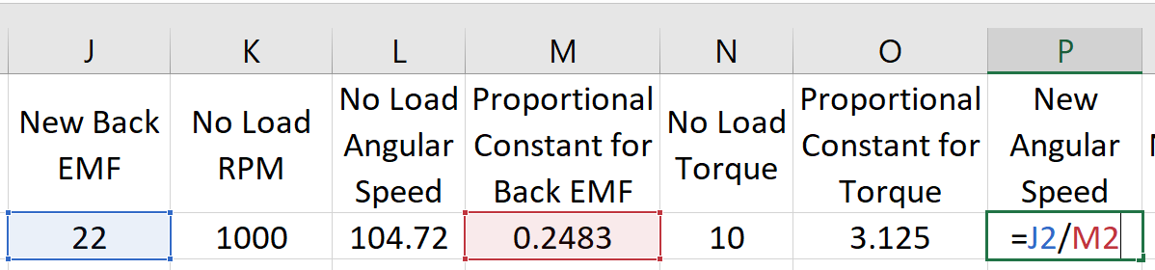

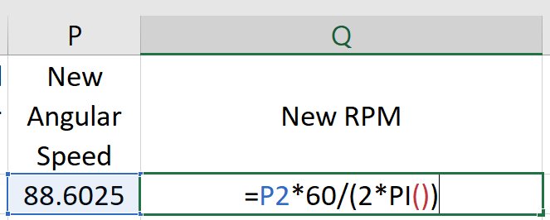

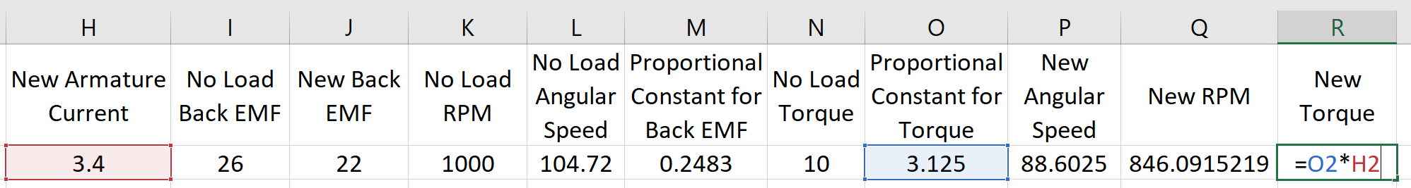



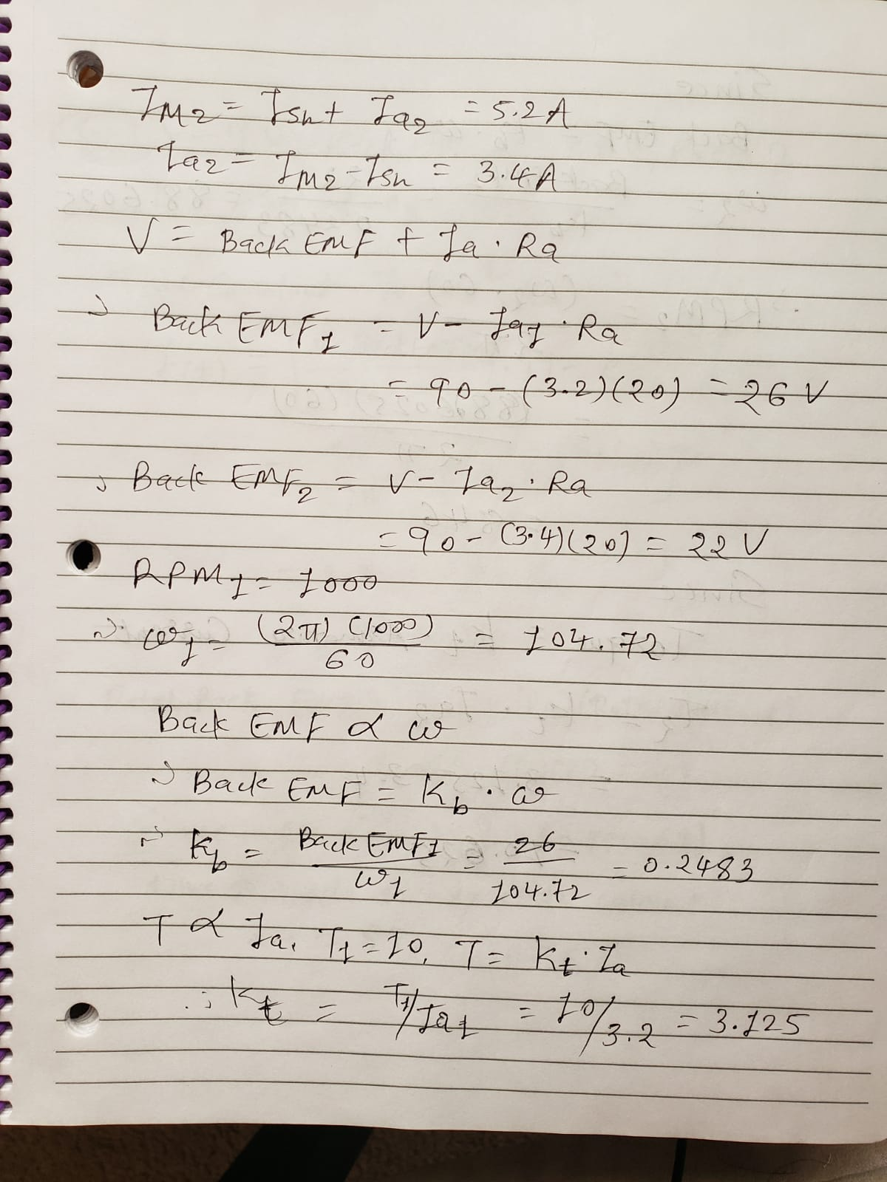

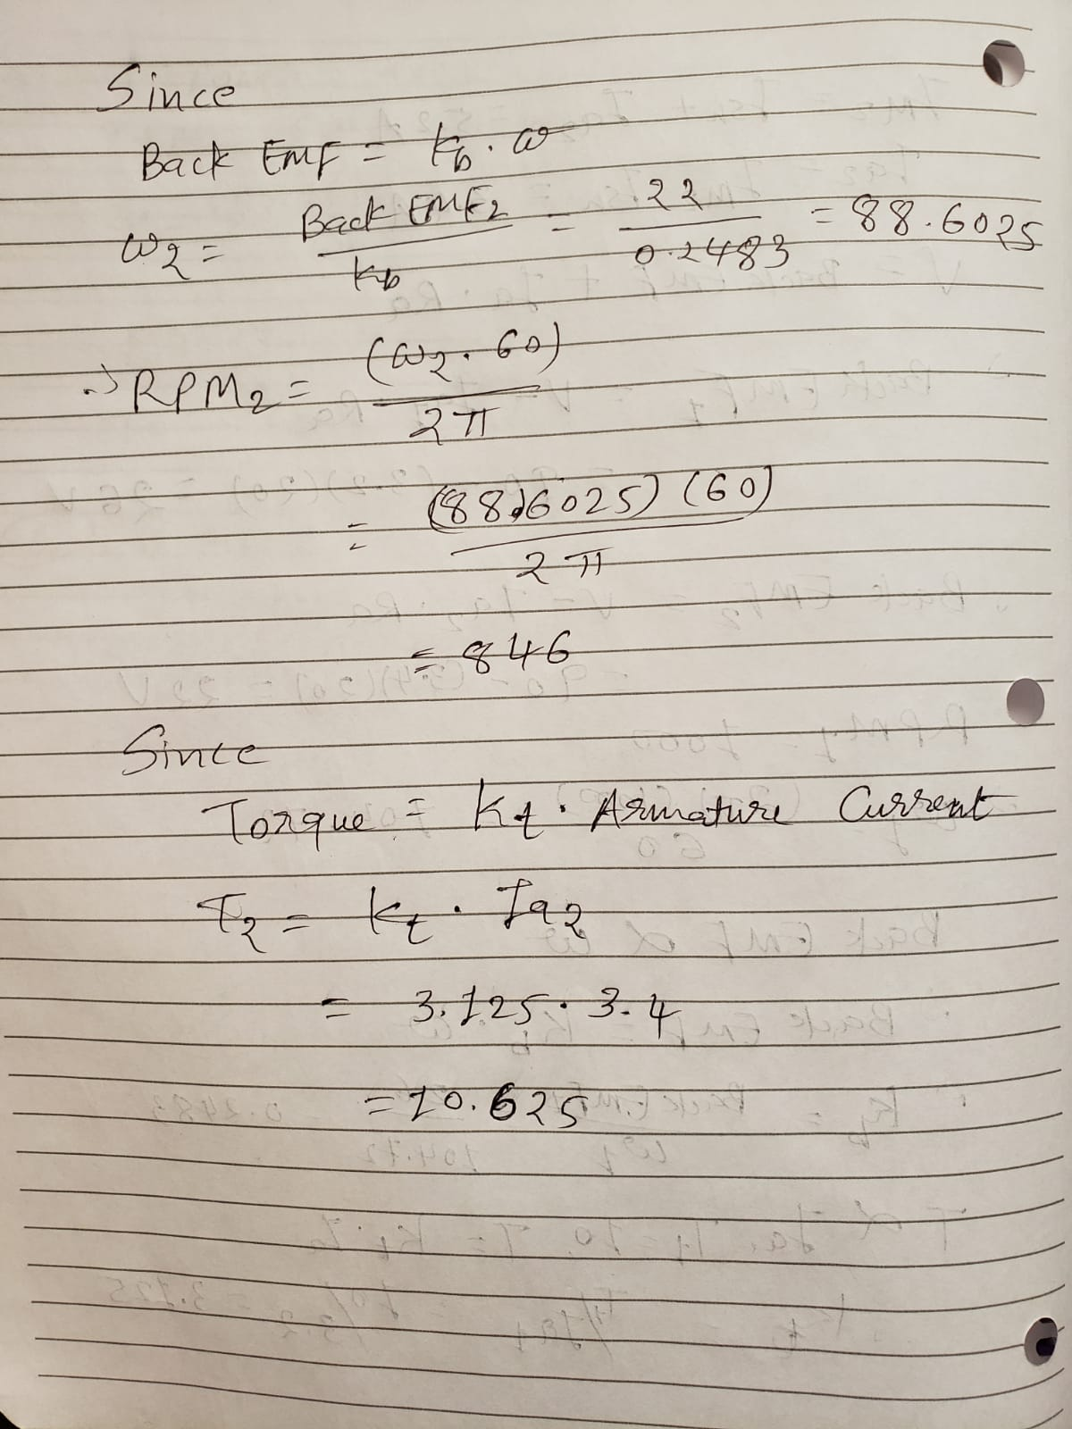

1. A permanent magnet DC motor is accelerating to its rated speed, but it has not quite reached this speed by time t. The motor has the following attributes:



What is the motor current at time t?

Answer: **2.798A**

What is the time constant of the motor?

Answer: **0.15s**

Approximately at what time will the motor reach its rated speed?

Answer: **0.75s** (from the graph below)

What is the back EMF at the rated speed?

Answer: **60V**

Reference: [**[3]**](https://www.mathworks.com/examples/matlab/community/36094-influence-of-permanent-magnet-dc-motor-parameters-on-starting-transient-process)

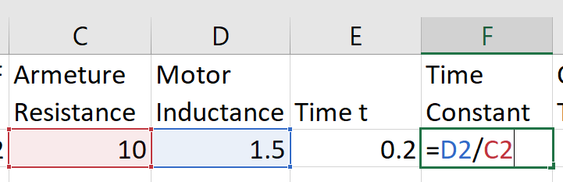

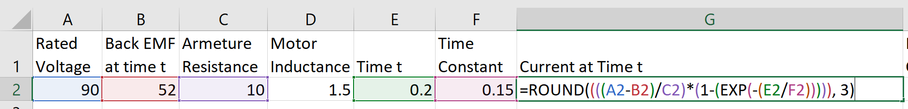

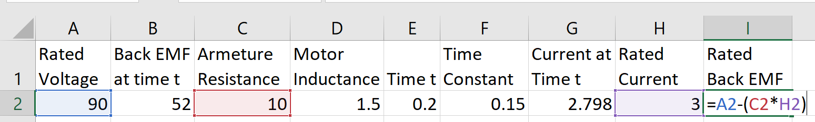

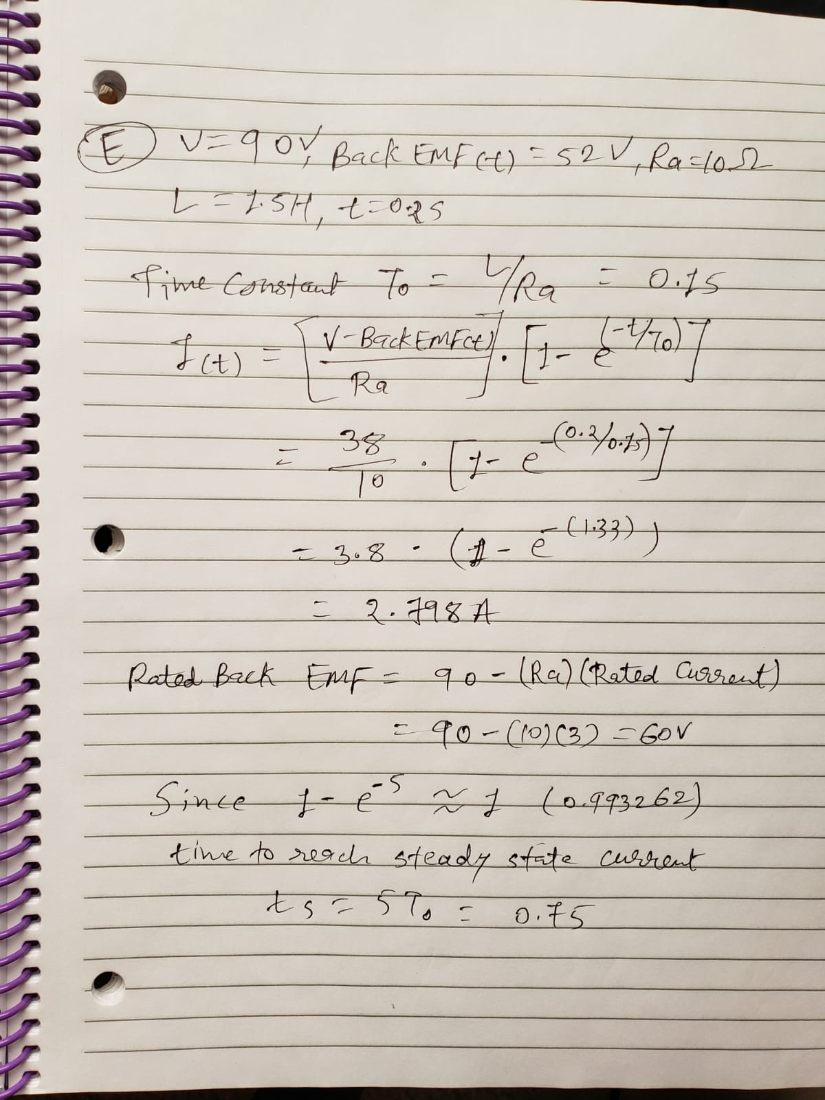

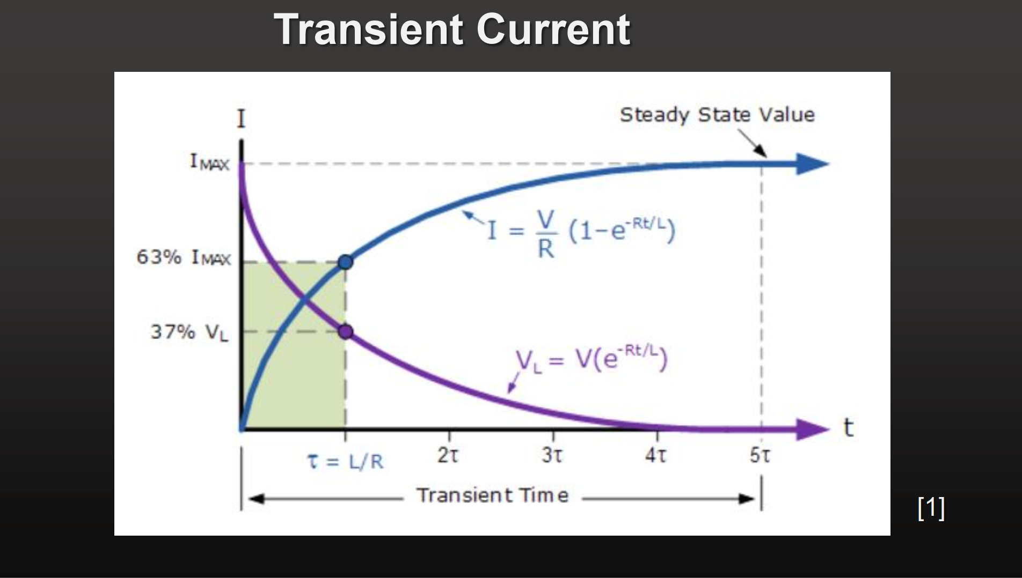

1. How do you know that the compound motor provides good speed control at the no-load condition?

Answer: **The compound motor** is the combination of series-wound DC motor and shunt-wound DC motor. This is achieved in a way that it **advantages from both configurations**. The shunt-wound DC motors are known to have a good speed control at the no-load condition, while the series-wound DC motors are known to have solid starting torque [**[4]**](https://www.electrical4u.com/compound-wound-dc-motor-or-dc-compound-motor/) . **As a result, compound motor has a high starting torque which resists the efforts of external load to slow down the speed of the motor, while also having the ability to fight it using the speed control characteristics of shunt wound DC motor. Resultantly, the compound motor has a really good speed control at no-load condition.**

In shunt-wound DC motors, the speed control is achieved in the following way. The back EMF generated is proportional to angular speed of the motor, and the Torque is proportional to the armature current. Also, the armature current is inversely proportional to the back EMF – because as the back EMF decreases, net voltage on armature increases – resulting in more current flowing through the armature. Increased current directly translates into more torque to fight whatever the force is there slowing down the motor, and therefore automatic speed control is achieved – as the external load will only translate in more torque and speed simultaneously [**[5]**](https://www.electrical4u.com/shunt-wound-dc-motor-dc-shunt-motor/) .

1. Describe how trapezoidal commutation works. You can use one or more of the slides from our lectures for pictorial representation, if you like.

Answer: **The basic idea is to switch 3 phases, among 3 different values (negative voltage, zero, positive voltage) and have a number of combinations resulting in 6 states - which makes the rotor rotate** [**[6]**](https://e2e.ti.com/blogs_/b/motordrivecontrol/archive/2013/11/08/generate-your-own-commutation-table-trapezoidal-control-3-phase-bldc-motors-using-hall-sensors) **.**

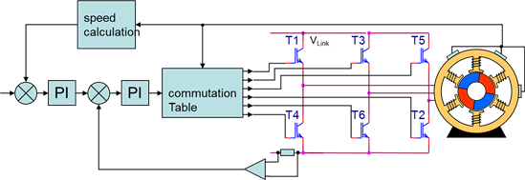

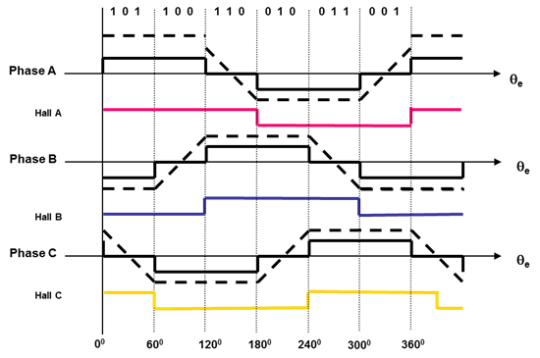

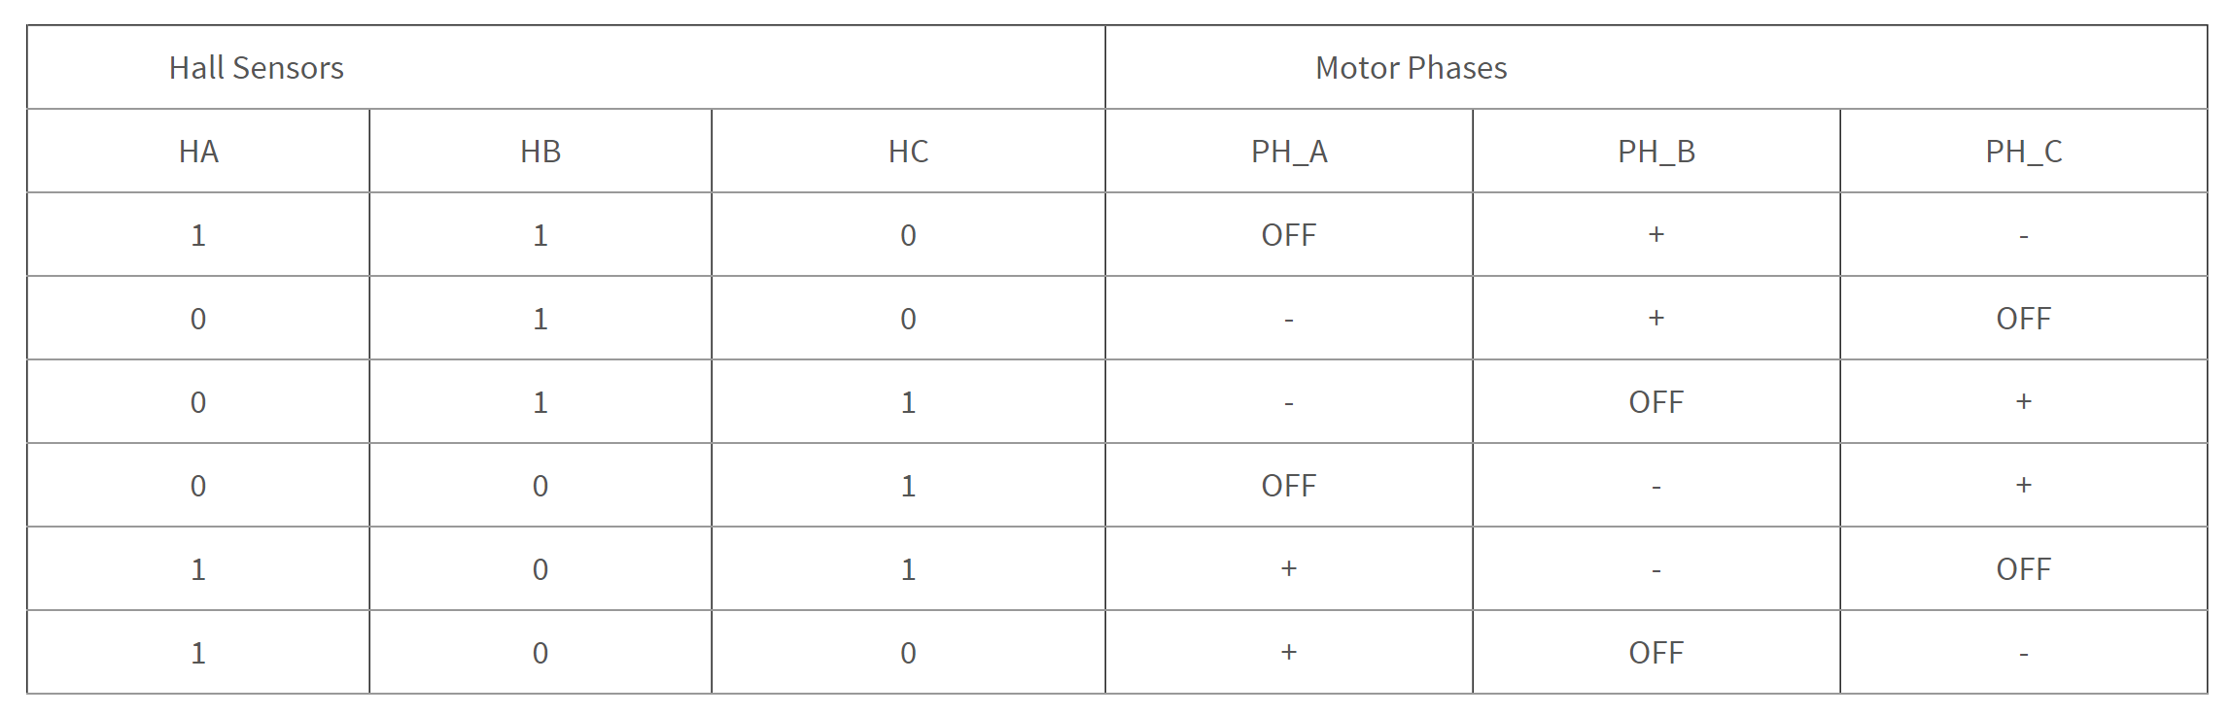

In detail, all of the states can be explained using below figures:

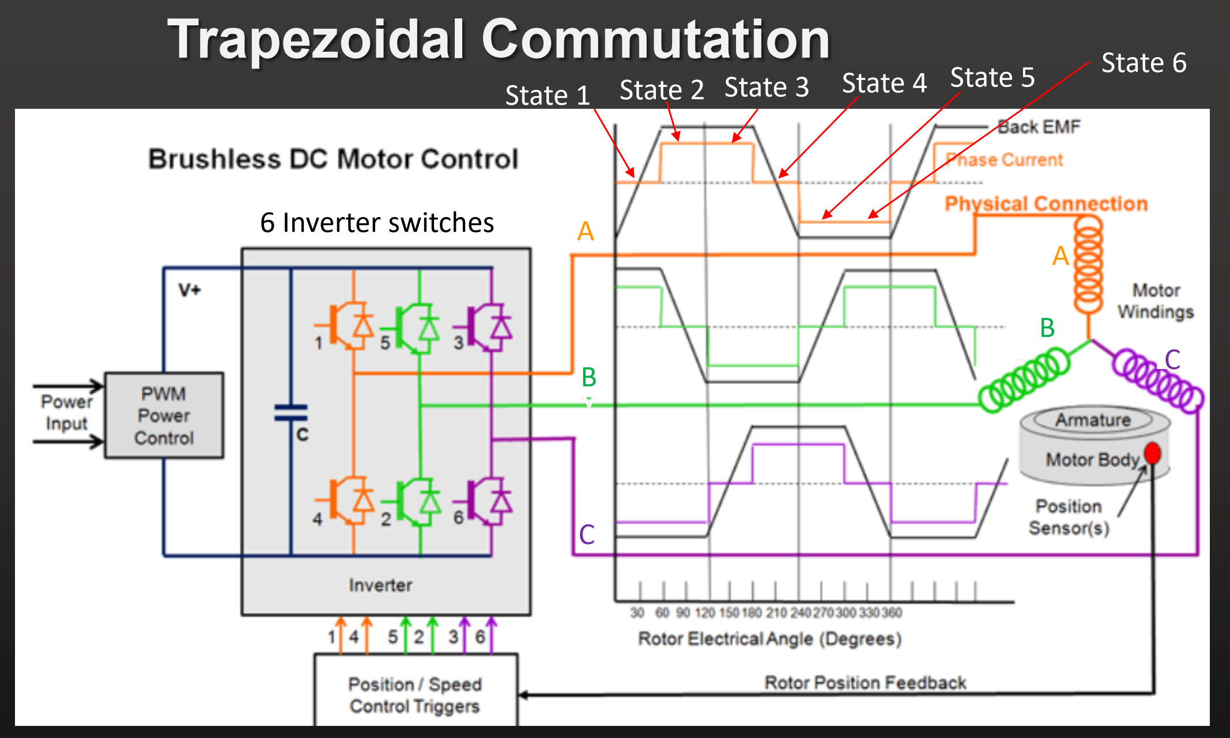

**STATE 1 – North Poles – B1, C1; South Poles – B2, C2**

**Phase A – OFF, Phase B – Positive, Phase C – Negative**

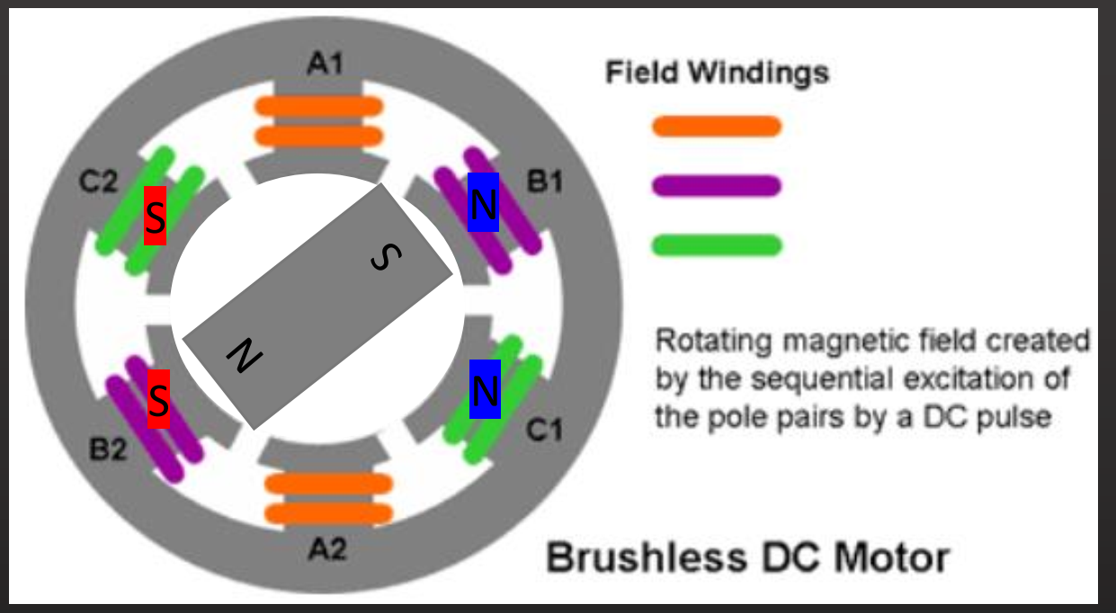

**STATE 2 – North Poles – A2, C1; South Poles – A1, C2**

**Phase A – Positive, Phase B – OFF, Phase C – Negative** 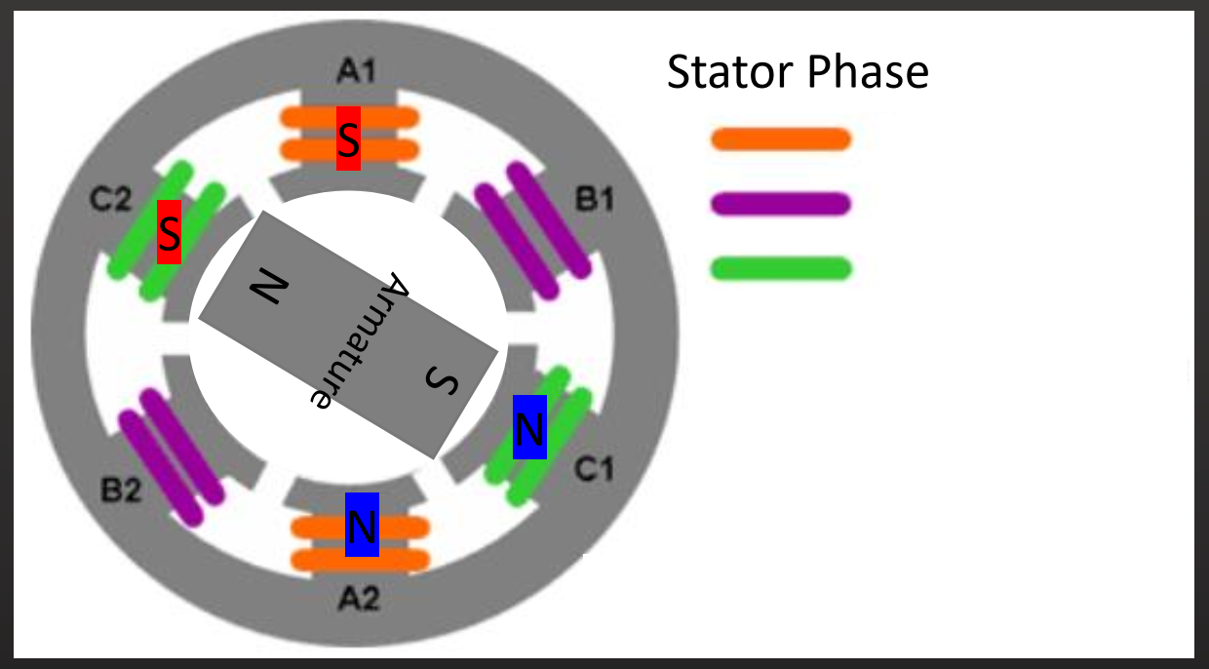

**STATE 3 – North Poles – A2, B2; South Poles – A1, B1**

**Phase A – Positive, Phase B – Negative, Phase C – OFF** 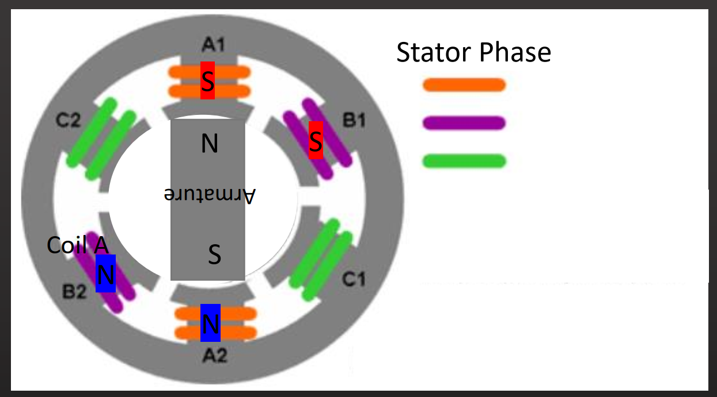

**The figures for last 3 will follow the pattern of first 3 (exactly the same with all poles reversed in polarity)**

**STATE 4 – North Poles – C2, B2; South Poles – C1, B1**

**Phase A – OFF, Phase B – Negative, Phase C – Positive**

**STATE 5 – North Poles – C2, A1; South Poles – C1, A2**

**Phase A – Negative, Phase B – OFF, Phase C – Positive**

**STATE 6 – North Poles – B1, A1; South Poles – B2, A2**

**Phase A – Negative, Phase B – Positive, Phase C – OFF**

1. Describe how sensorless position monitoring works. You can use one or more of the slides from our lectures for pictorial representation, if you like. What are the flaws in this method of measuring angular position of the armature?

Answer: **Using the trapezoidal waveform of the generated Back EMF, and Back EMF zero crossing detectors of all 3 phases, a system can be developed which monitors the position of the rotor without having to use hall sensors** [**[7]**](https://www.digikey.com/en/articles/techzone/2013/jun/controlling-sensorless-bldc-motors-via-back-emf) **.**

This is described below:

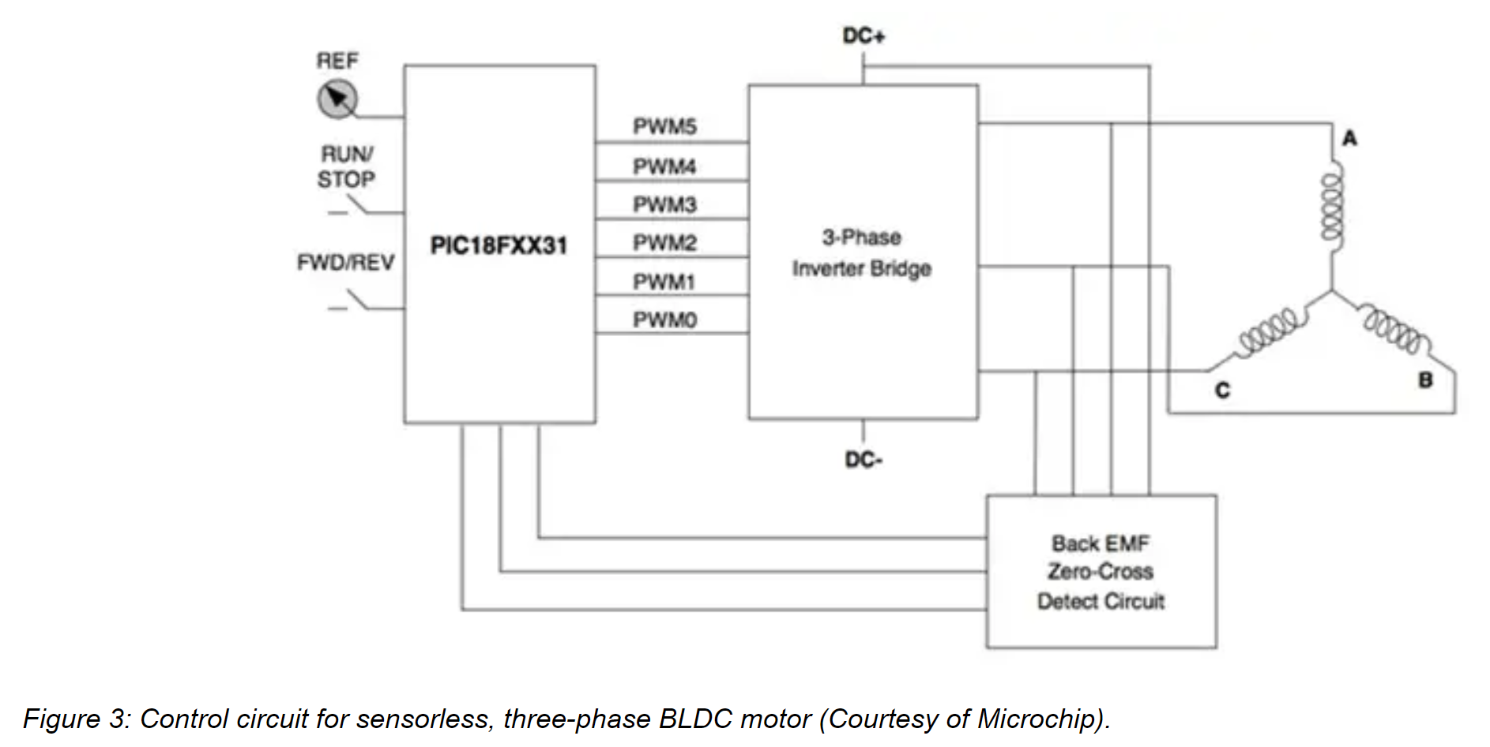

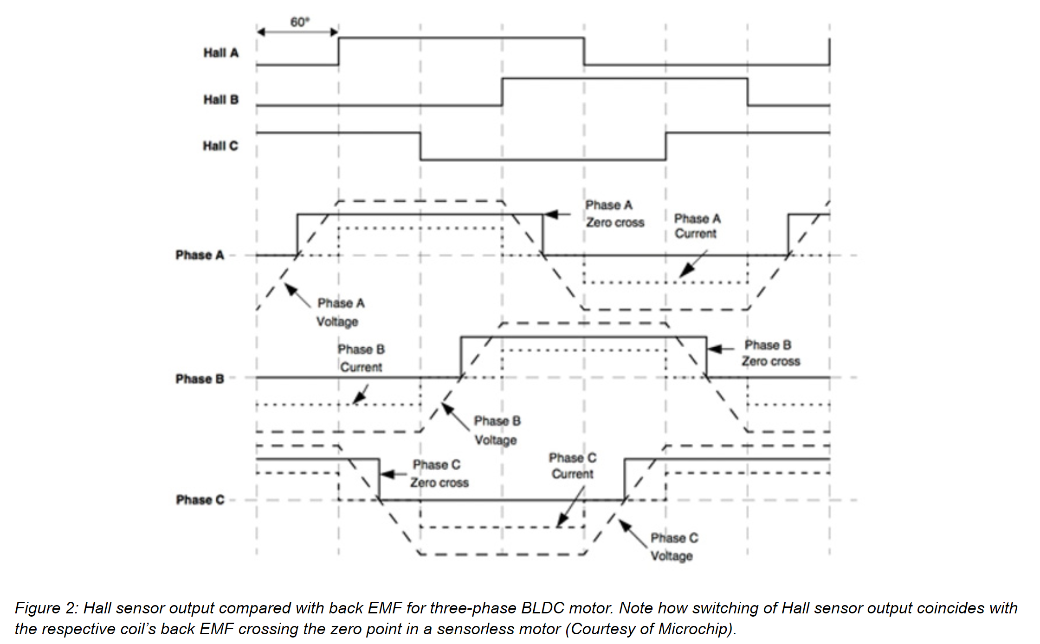

In the sensor less variant of the BLDC motor, there are no Hall-effect sensors. Instead, as the motor rotates, the back EMF in the three coils varies in a trapezoidal waveform (long-dashed lines) shown in Figure 2. For comparison, the same figure also shows the outputs from the Hall sensors of a similarly configured motor.

A combination of all three zero crossing points for the coils is used to determine the coil energizing sequence. Note that there is a phase difference between an individual Hall sensor changing output in a conventional BLDC motor, and the back EMF zero crossing point for an individual coil in a sensor less unit of 30 degrees. Consequently, in a sensor less motor control circuit, after the zero crossing point is detected, a 30-degree phase lag is built into the firmware before the next action in the energizing sequence is activated. In Figure 2, the short-dashed lines indicate the current in the coils.

Figure 3 shows a control circuit for a sensor less three-phase BLDC motor. In this case, the circuit uses a Microchip PIC18FXX31 8-bit MCU to generate the pulse width modulated (PWM) outputs to trigger the IGBTs or MOSFETs in the three-phase inverter bridge. The MCU reacts to input from a back EMF zero-cross detect circuit.

In conclusion, the process goes like this: **When back EMF of phase x crosses zero – from negative value to positive value, after some phase shift (delay) – the hall sensor x output (would) go from digital ‘0’ to digital ‘1’ – and vice versa. This information is used in firmware development and thus, sensor less position monitoring is achieved.**

1. An Hp Officejet 4500 wireless printer is shown printing a document in the photo below. After printing hundreds of documents, you normally need to change either the black or color inkjet cartridge. To do this, you flip down the black plastic door in front of the printer, revealing the two inkjet cartridge printers.

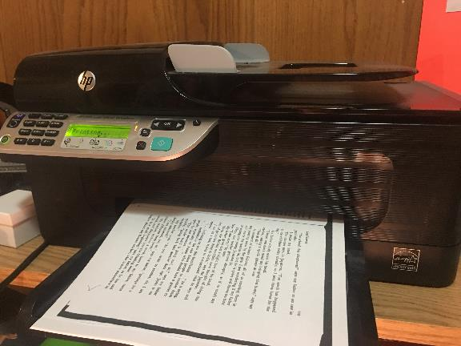

You note that the inkjet cartridges are conveniently positioned on the right side, so that you can easily change one or the other. (See photo below). The color one has the pink plastic top, and the black one has the black top.

A picture containing indoor, cabinet

Description generated with high confidence

You wonder how the inkjet cartridges got there, until you realize that they must be able to move across the paper to print your documents. There must be a mechanism that moves the cartridges.

Further inspection reveals a thin rubber belt drive connected to a DC motor, as shown in the photo below. As the motor rotates, the belt pulls the cartridges across the printer.

The edges of the belt are tangent to the outside diameter of the motor. A planetary gear head reduces the speed of the motor and increases the torque, so that a pulley attached to the motor rotates the belt at the proper speed and with the proper tension. The planetary gear head is the same diameter as the motor.

Rotating the motor clockwise moves the cartridges to the left and rotating it counterclockwise moves the cartridges to the right. A pulley on the other side of the printer rotates on a bearing. It is the same diameter as the pulley on the left, so that the pulleys do not provide a gear ratio to provide the torque to move the belt. Only the planetary gear mechanism does this function.

A picture containing indoor, cabinet

Description generated with high confidence

Rubber Belt

DC motor

Rollers for paper drive

One day, the motor breaks, and you can no longer print. You check your paperwork, and the printer is out of warranty. Rather than buy a new printer, you decide to replace the DC motor. With the aid of your class professor, you establish the following specs for the motor drive system.



Reference: [**[8]**](http://www.sci.brooklyn.cuny.edu/~kammet/gear_notes.pdf)

What is the output rotational speed of the planetary gear system?

Answer: **129.936 RPM, 13.6 Rad/Sec**

Belt speed is linear, while output of the planetary gear system would be rotational. We have the diameter of the motor, using which, we can find the circumference of the gear driving the belt, and thus, find the rotational speed. First, converting linear speed into meter per second:

v = 0.17 m/s . Circumference = π * diameter ≈ 0.0785 m. This is also the measure of linear distance travelled by gear in one revolution. To find RPM or revolutions per second, 0.17 m/s velocity means that in 1 second, the belt would have travelled 0.17 meter. Therefore, RPM = (0.17 / 0.0785) * 60 ≈ 129.936

Converting this to angular speed, ω = (2*π*RPM) / 60 ≈ 13.6 rad/sec

What is the torque output of the motor?

Answer: **8.928 N-mm**

The output torque of the planetary gear system is given as 500 N-mm. The gear ratio is 56 – which essentially means that the output torque of the motor is multiplied by 56 times. Thus, motor torque = (500 / 56) N-mm = 8.928 N-mm.

What is the rotational speed of the motor?

Answer: **7276 RPM, 761.554 Rad/Sec**

The rotational speed of the motor is reduced using gear system (to get more torque), and thus, motor speed = (56) * (129.936) ≈ 7276 RPM ≈ 761.554 rad/sec.

Once you have these specs, go the web site [www.nbleisonmotor.com](http://www.nbleisonmotor.com) and select a suitable motor for the printer. Make a screen shot of its part number and specs.

Answer: **RS-380SA-3270** [**[9]**](http://www.nbleisonmotor.com/RS-380-Dc-Micro-Motor-pd6103204.html)

This motor meets almost all the requirements with minimum voltage being 3V, max efficiency RPM being 7800 RPM and 7.8 N-mm torque. 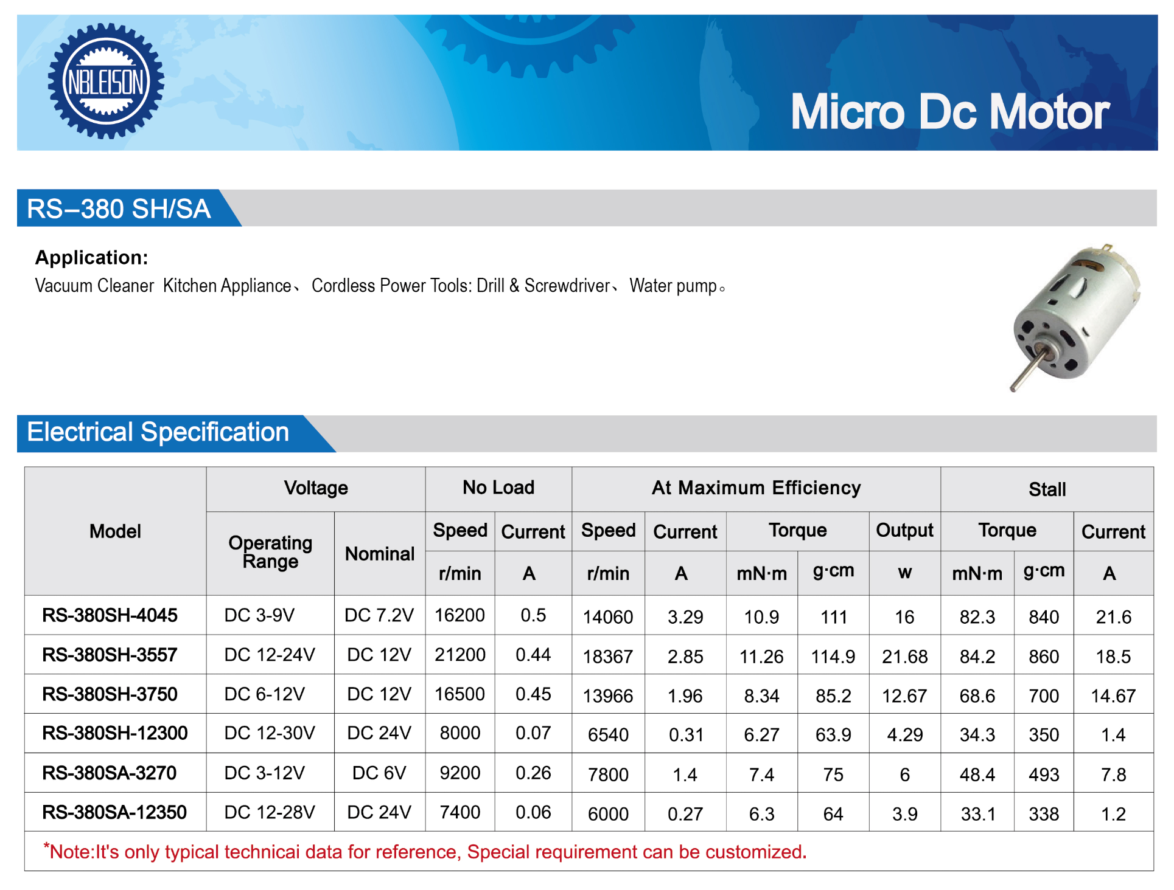

1. Suppose you create a Lorentz Force by passing a current through a conductor located in a magnetic field. What would happen to the Lorentz Force if you reversed the direction of both the magnetic field and the flow of current at exactly the same time? Why would this happen?

Answer: **The direction of the Lorentz Force being applied on the conductor would remain in the same direction.**

The direction of Lorentz Force could be found out using right hand rule, as per the below figure [**[10]**](http://hyperphysics.phy-astr.gsu.edu/hbase/magnetic/magfor.html) :

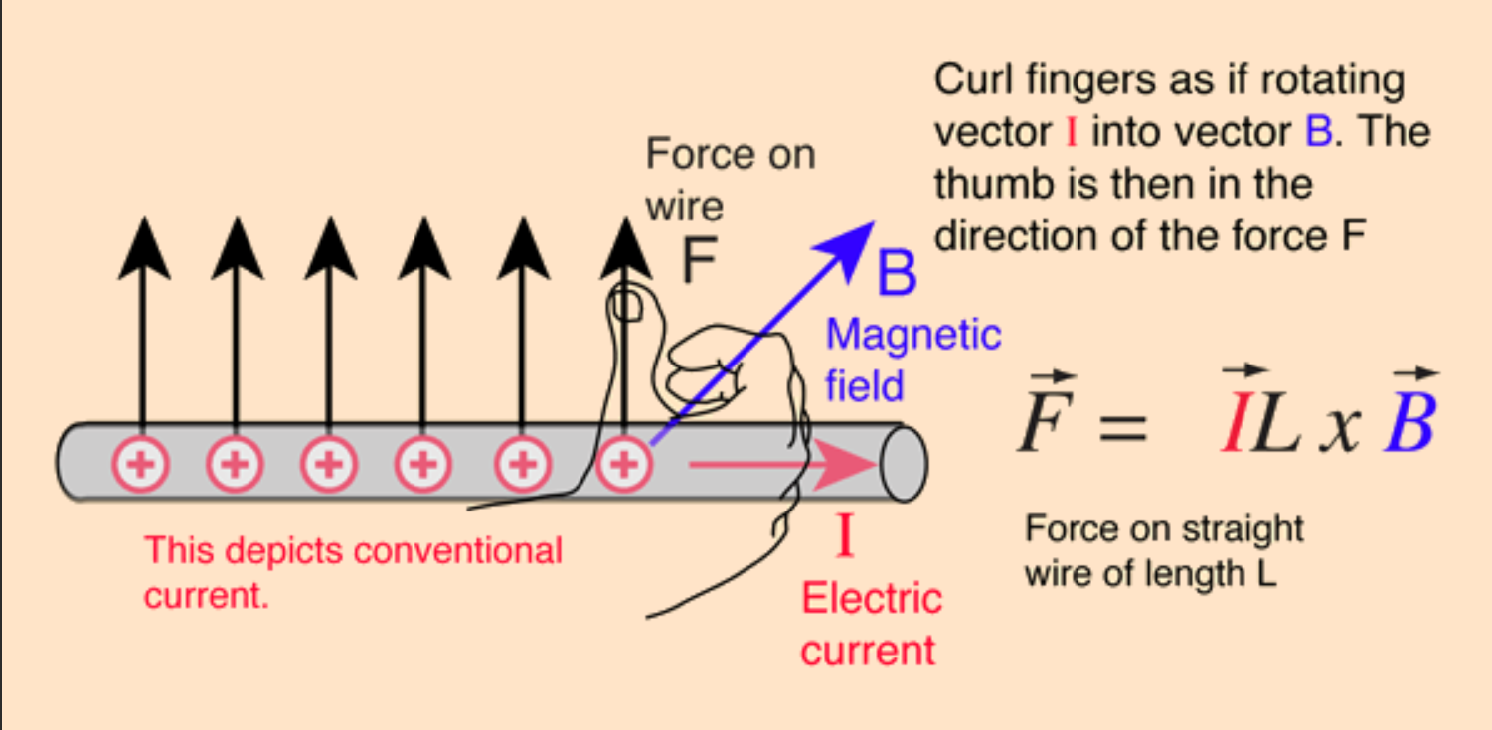

Now when the direction of electric current, and magnetic field – both is changed, the hand simple rotates around the vertical axis, keeping the resultant direction of the force – same.